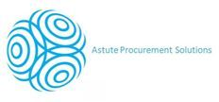**June 2012  
see us at www.apsconsulting.net  
speak to us at 0844 2646411  
email us at info@apsconsulting.net**

**Welcome to our June newsletter.**  
This year has flown past so far and APS are experiencing increased growth and opportunities within procurement and cost reduction. As the economic climate tightens yet again and growth reports have been reduced by the Bank Of England many businesses are now taking the positive step of looking at ways in which costs and expenditure can be reduced.

**“Astute Procurement Solutions deliver proven energy and utilities cost efficiency and streamlining to small, medium and corporate companies”.**

**Ashdown Hurrey & Spectrum**



APS carried out an audit of Gas, Electric, Water and Stationery supplies. APS found new suppliers for all services which led to contracts being signed offering the company savings of around 30% across the services selected. An ongoing relationship has now begun recommending the APS solutions to Ashdown Hurrey and Spectrum clients.

**APS would be delighted to meet with you and discuss how we can make your business more cost efficient and streamlined.**

Visit our website to see how our Business Optimisation Support Service software works;

<http://www.apsconsulting.net/boss.html>

**This month’s customer reference.**

http://www.apsconsulting.net/images/DraiFineArt.jpg

“We have recently launched our website and wanted to make sure we did everything we could to make sure we provided our clients with a safe online payment solution. The PCI standadrds are very complex and as a small business we dont have the expertise to know exactly what is required and what we needed to do. APS Consulting provided us with an expert in this field who was able to bridge the gap between the jargon and provide us with a plan of action. I came away knowing the main issues which I needed to work on. The advice was very honest and I received further information and advice after the consultation. I would certainly recommend APS Consulting” Stuart Daw – Director.

**Want to be “Green?**

The move to being seen as a “greener” company can be seen by many as a long hard road ahead. APS recognise that for many time is not available to explore the potential of sustainable and renewable topics such as solar, heat pumps, LED lighting. APS now offer a solution to this dilemma. Using vetted partners APS can access your “Green” requirements and produce a road map report for delivery.

This month we have dedicated the following section to provide you with an insight to the emerging energy saving technologies, which APS are able to provide via our partner KRA Technical.

**ICF Construction “Greener Building”**

APS can now offer code 5 and 6 construction of housing at build prices in many cases lower than traditional build prices. Our client offers build at circa £850-£900psm depending on design, and specification. The product is offered on a modular format and a test site can be seen in Woking Surrey for any companies interested.  A full renewables product range can also be offered for the heating, lighting systems etc internally to ensure maximum efficiency is obtained for these buildings.  
  
Construction can be:  
[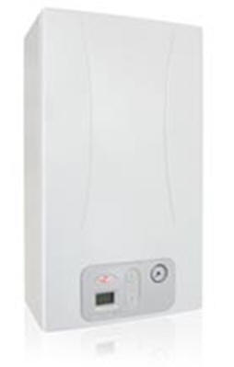](http://www.kra-technical.com/VOLANTINO%20ANTEA%20COND.%20BAND%20A%20rev2-%20GB.pdf)Skeleton  
Shell and Core  
Fully finished product.

 The build rate is rapid for example a recent development of 4 semi detached houses and 2 apartments was to first floor level in 7 days with a workforce of four and a recent construction of a  5 bedroom individual detached house in Bath was completed within 30 days.

**“Investors & Developers”**

**Come & Join us for our**

**ICF Open Day**

**22nd June 2012 11.00 – 13.00 ICF Build Solution & Event at Woking, Surrey**

Event to be held at our ICF Build site in Woking showing a fully working site and build in progress. Meet and discuss ICF build with our experts.

**Please RSVP by emailing us your full contact details to:** [**info@apsconsulting.net**](mailto:info@apsconsulting.net)

**Additional Services for ICF Build.**

**Aluminum Radiator Systems**

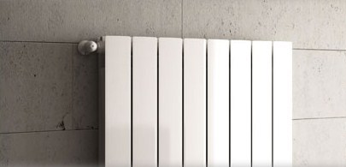Reduce energy use and costs by up to 21%  
10 Year Warranty Std / Option 20 years  
Low temp design only 50ºc Flow required  
Ideal for heat pump systems  
Modular Design easy to add/remove sections

**Condensing Combi Boilers**

**Reduce heating costs by up to 21%**

Compact wall hung high efficiency condensing combi boiler & Aluminium radiator "Packs Available" in 24 kW and 28 kW.

Pre-set for Natural Gas or LPG.

“ONLY 250mm Deep”

High-efficiency thermo-polymer and  
stainless steel heat exchanger.  
Modulating combustion fan   
3-speed circulation pump with in-built de-aerator  
Flame modulation in heating and DHW  
Wide modulation range 1:9  
Low power consumption in stand-by (2.3 W) in accordance with EuP Directive

**Heat Pumps**

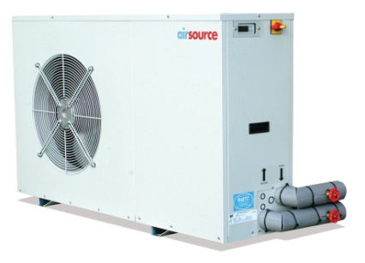

Using our Air source heat pumps with 65ºc flow temperature, connected through any of our Thermal stores to Aluminium radiators designed for low temperature (50ºc) systems, KRA can now bring you the ideal solution for any heating system, without any concerns about the energy and hot water produced by the heat pump providing sufficient heat in winter.

**Under Floor heating**

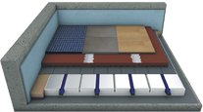

Through our close association with Jupiter Under-floor heating, one of the leading names in under-floor heating system, we are pleased to offer the systems as below.

Using modern technology we can supply a `Dry-Fit` no screed under-floor system that is capable of being able to supply balanced heating  across the surface of a floor. A Dry system is also more economical to run and faster to respond to weather compensation.

System Benefits:                                                         
Immediate use after installation / no day per mm drying times  
Only 50mm build height increase on solid floor  
1.5Kn/point loading up to 5Kn point loading  
Cover with engineered wood floor or Thermal conducting tiles or your choice

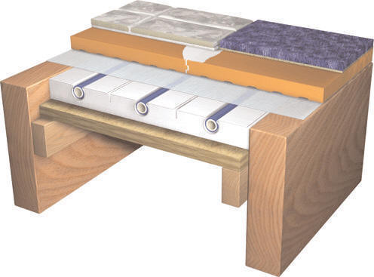

We are able offer the following;

Bespoke design to suit YOUR building (s)

Design and supply service (or) Design, Supply and Professional installation

Wet Room system available (Walk in Shower - Ideal disabled access)

Between Joist systems

+ A Unique System made from recycled wood Waste

**“Hot off the Press”**

**APS** are delighted to announce that they have signed agreements to become an accredited partner of **Keseco UK Ltd**, to distribute their unique patented “Current Optimisation” energy efficiency technology, “**ULTRA”. Please contact us for more information.**

**APS would be delighted to meet with you and discuss how we can make your business more Energy & Cost Efficient, so for an initial FREE audit please give us a call on 0844 264 6411.**